Digital Forensics

Mohammad Hamad

MSCS(16-18)

Assignment No. 2

**File System: FAT32**

Step 1: Using hexedit or any other hex editor analyze your evidence image file as createdin assignment 1.

1. **No. of partitions: 1**

**Start sector no.: 0x00000200**



**End sector no: 0x000003f0**



1. **File system type of partition: (FAT32)**



1. **Snapshot of Boot Sector/MBR:**

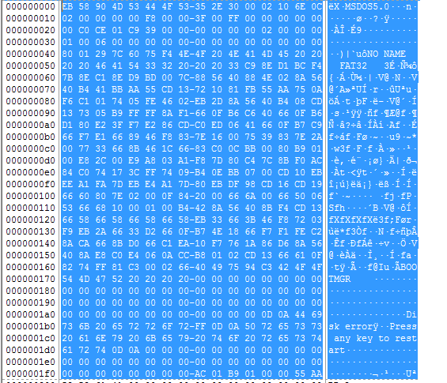

1. **Sectors per cluster:**



1. **Size in sectors for Reserved area:**



**0x0C6E*0x200 =18DC00**

1. **Number of FATs:**



1. **Total sectors in file system:**



**Bytes= 0x00C0CE01 =12635649 sectors**

1. **Starting address of root cluster:**



1. **Starting address of FAT: (18DC00)**



1. **Snapshot of file entry in root directory/MFT:**
2. **Size of File:**

**File System: NTFS**

Step 1: Using hex-edit or any other hex editor analyse your evidence image file as createdin assignment 1.

1. **No. of partitions: 1**

**Start address: (0X00000200)**



**End address: (0x000003f0)**



1. **File system type of partition: NTFS**



1. **Snapshot of Boot Sector/MBR**

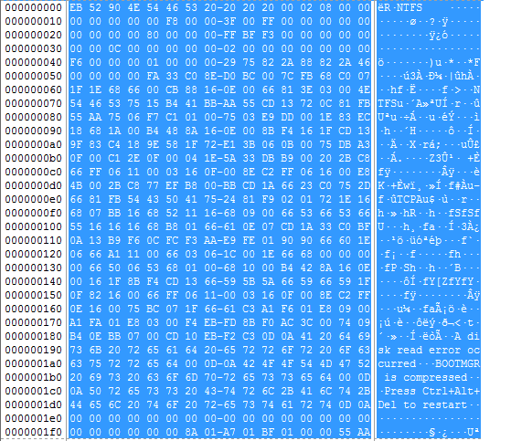

1. **Sectors per cluster: (0X08)**



1. **No of sectors: (0XF3BFFF=15974399sectors)**



1. **Starting address of MTF:**

**(0X0C0000*0X200*0X08=0X** **C0000000)**



